ML Projecttttttt
-1 more clarity on the exact models you want to use and the feature for each of them.
-0.5 more explanation on missing data, lack of independence of multiple observations of the same whale, etc.

For your project proposal, here are a few things to clean up?
- Narrow the scientific question. Right now, you have several related questions. Separate the demographic habitat-use question from the calving-success question.
State clear hypotheses. For each question, say what you expect to happen biologically (e.g., demographic groups differ in regional habitat use or prey-associated habitat use predicts future calving).

Think of this as a mini-grant proposal (2 pages, single spaced, 11 or 12 pt font) The proposal should make it possible for a reviewer to understand what you will do, what evidence will count as success, and how you will avoid common ML pitfalls. Your proposal should be written so that a scientifically trained reviewer outside your exact subdiscipline can evaluate the significance, rigor, and feasibility of the work. The proposal will be reviewed using criteria modeled on NSF-style peer review, with particular emphasis on intellectual merit and broader impacts.

Required content
- Intellectual Merit: Explain the scientific or technical contribution of the project. Why is the problem worth investigating, and what could the analysis teach us that matters scientifically?
- Broader Impacts: Describe who could benefit from the work, how the results could inform management, decision-making, education, public understanding, or other societal needs, and any relevant data/technology or community considerations.
- The proposal must also include:
- The scientific background to the project
- Scientific question and hypotheses/expected relationships, where appropriate.
- Dataset information, including source and processing/filtering.
- Preprocessing plan: transformations, imputation, scaling, encoding, feature engineering/selection, and how steps avoid leakage.
- Train/validation/test strategy with justification; explicitly address temporal, spatial, or grouped dependence.
- Modeling plan: baseline, primary model(s), and comparison model(s); explain what each comparison is intended to show.
- Evaluation metrics and success criteria, with justification.
- Interpretation plan: errors, feature/model behavior, uncertainty, partial dependence or other relevant diagnostics.
- Limitations, risks, and a fallback plan if initial modeling does not work well.

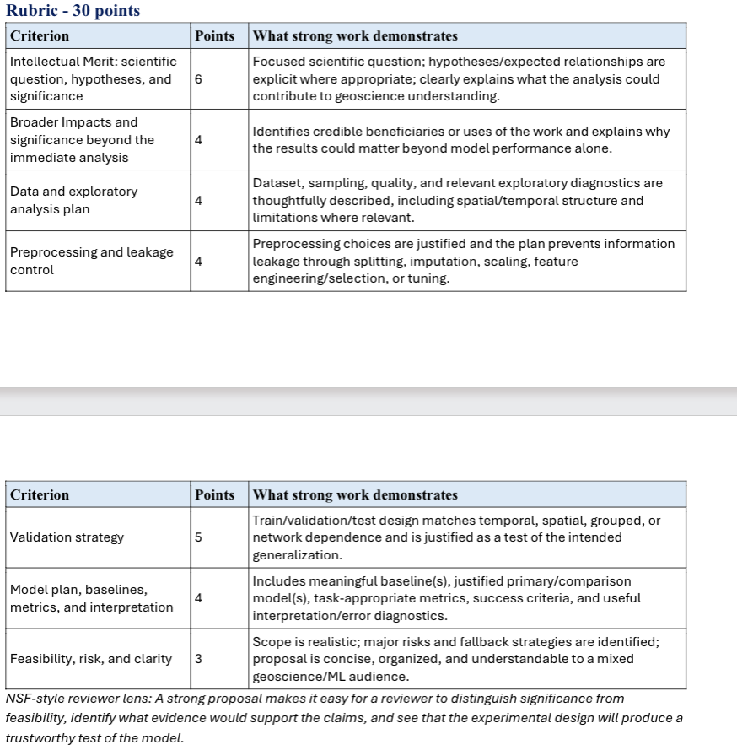

https://link.springer.com/article/10.1186/s13717-024-00532-6
- Assemblages of plankton- assemblages of whales
Demographic distribution comparison
- Structural Similarity (SSIM) Index

Similarity index for months and years – grouping ??? decade

Novel application of a quantitative spatial comparison tool to species distribution data

Comparing geographically referenced maps has become an important aspect of spatial ecology (e.g. assessing change in distribution over time). Whilst humans are adept at recognising and extracting structure from maps (i.e. identifying spatial patterns),...
- and demographic

Cetacean species at relatively high bycatch exposure were further analysed using the Structural Similarity Index (SSIndex) (Jones et al. 2016), implemented through the ‘raster’ package (Hijmans 2017). The SSIndex is a spatial method that facilitates comparison between two geographically referenced maps using a local moving-window approach. The index computes three complementary metrics: similarity in mean (SIM), similarity in variance (SIV) and similarity in pattern (SIP) between the compared maps. This study focused on SIP, as it provides relevant information for analysing local-scale spatial associations between cetaceans and fisheries. SIP analyses the overlap of clustering between the compared maps (here gillnet fisheries and cetacean species), revealing local-scale similarities and differences in spatial use patterns (Jones et al. 2016). SIP is measured as the ratio of local covariance to the product of local standard deviations and ranges from −1 to 1. A value of -1 indicates a negative spatial correlation, suggesting spatial segregation between cetacean habitat suitability and fisheries activity. A value of 1 indicates a positive spatial correlation, with high or low values occurring in the same cells. Values close to 0 indicate little or no spatial relationship between the compared maps. To conduct the SSIndex analysis, we considered both gillnet catches and cetacean habitat suitability per unit area. Habitat suitability and fisheries catch values were normalized to a scale from 0 to 1 to facilitate comparison. Cetacean habitat suitability was estimated using Environmental Niche Models based on the Maximum Entropy algorithm (Maxent), a machine-learning method widely used and robust to predict species occurrence (Phillips et al. 2006). We analysed the MARSPEC database (Sbrocco and Barber 2013) using multivariate analysis, retaining the 11 most informative environmental variables for habitat modelling, including variables related to bathymetry, seabed slope, sea-surface temperature
- Species distribution
- – mixed effects model
Machine learning for the spatial comparison of geospatial data uses location-aware algorithms to quantify differences, detect pattern changes, and align multiple raster or vector layers across geographic space. [1, 2]
Key Concepts & Challenges
- Spatial Autocorrelation: Nearby geographic points are often related, which violates standard independent data assumptions and requires specialized handling like spatial cross-validation. [1, 2]
- Multimodal Data Structures: Comparing continuous raster surfaces (like satellite imagery or elevation grids) with discrete vector layers (like administrative boundaries or roads). [1]
- Spatial Heterogeneity: Relationships between variables can change from one region to another, making local comparisons more reliable than global summaries. [1]
Common Machine Learning Approaches
- Convolutional Neural Networks (CNNs): Ideal for image-to-image or raster comparison, such as tracking land-cover change over time or identifying structural damage using multi-temporal satellite data. [1, 2]
- Random Forest & Support Vector Machines (SVMs): Effective for classifying tabular or multi-layered raster features to map categorical differences across distinct regions. [1, 2]
- Clustering & Dimensionality Reduction (K-Means, Self-Organizing Maps): Used to group spatial profiles and segment regions into distinct homogeneous zones for cluster-to-cluster comparison. [1, 2]
- Explainable Spatial Frameworks (e.g., GeoShapley / Geographically Weighted ML): Combine local spatial weighting with machine learning to measure how individual geographic features drive local variances. [1, 2]
Essential Python Tools
- Geospatial & Geometry Handling: GeoPandas, Shapely, and Rasterio for vector and raster data preprocessing.
- Spatial Statistics: PySAL for exploratory spatial data analysis and autocorrelation metrics.
- Core Machine Learning: Scikit-learn alongside deep learning frameworks like PyTorch or TensorFlow. [1, 2]
If you'd like to dive deeper, let me know:
- Are you comparing raster images (satellite/aerial) or vector datasets (points/polygons)?
- What is the specific analytical goal (e.g., change detection, anomaly identification, regional clustering)?

Classifier of M, F, J, A, Year
- ML question: can I predict whether a adult reproductive female calves depending on space use??
  - Effort
  - Area
  - Spatial chunking is ML!!!
  - Relate to the amount of time spent in good prey habitat
  - I would also like to see what prey layers best predict as well.
  - One ensemble ?? with all layers
  - Then like 3 separate ones
    - Carolyn’s, Bigelow’s, and Camille’s

Background & Questions
North Atlantic right whales are critically endangered species of baleen whale with an estimated 384 individuals remaining. Rapid warming in the Northwest Atlantic has caused interannual variability in right whale prey across seasonal foraging habitats. These fluctuations in prey abundance have been linked to annual right whale distribution and birth rates. Foraging patterns and regional habitat use varies between individuals. This can be due to different individual nutritional needs or social interactions related to demographic characteristics. Right whales have been highly monitored since the 1980s, and individuals can be identified by unique callosities and markings which provide a noninvasive opportunity to characterize individual space use over time.
This project will use a novel right whale movement modeling framework, which applies a Brownian-bridge to estimate space use by a uniquely identified individual right whale between consecutive sightings as a unit of whale days (e.g. Fig. XX). This model provides a 5-fold increase in knowledge of individual right whale distribution across their full habitat range relative to the complete North Atlantic Right Whale Consortium Identification Database (North Atlantic Right Whale Consortium 2025). The metric of whale days allows for spatial and temporal representation of habitat-use to be quantified and compared across individuals and time (Mu et al. 2026).
I will be investigating if calving by reproductive female can be predicted relative to the space use of that individual in regional areas, latitudinal zones, or exposure to prey in the two years prior to calving. By applying this novel method to investigate reproductive success, this project will be able to illuminate how sight fidelity and prey exposure impact species recovery and distribution. A healthy right whale calving interval is expected to be 3 years, where after the calf is born the mother lactates for a year, rests, and is pregnant for over a year. Right whale calving intervals have increased as birth rates have declined (Pettis & Hamilton report card??, Browning et al. 2010, Meyer-Gutbrod??). Calving right whales are in better body condition than non-calving whales, and overall decline in body condition has been related to declines in calving (Rolland et al. 2016). This suggests that foraging conditions two years prior to calving are for reproductive females to successfully reproduce. If right whale calving can be predicted from spatial distributions, that would allow for protection and further investigation of foraging areas and prepare managers for years when more whales will be traveling to the Southeast US to calve.
Methods: dataset and info
Right whales that give birth every year are identified in the North Atlantic Right Whale Consortium Identification Database as being “with calf” (North Atlantic Right Whale Consortium 2025). Reproductive females will be identified if an individual was ever seen with a calf. Those individuals’ space use distributions will be extracted from published outputs of Kreuser et al. 2026, and then for each individual, space use will be summed within regional and latitudinal zones for the 2 years prior to each calving season. Prey exposure will be calculated by overlapping space use with prey distributions of Calanus finmarchicus, Calanus hyperboreous, Pseudocalanus sp., and Centropages sp.. These prey distributions were calculated by collaborators at Bigelow using Boosted Regression Trees with EcoMon and AZMP data. Prey exposure will be calculated on a monthly time scale. In addition to prey and space use, effort in the regional areas will quantified, as on-effort days within the area by platform. Effort will be considered to have occurred if survey teams recorded Beaufort sea state ≤ 4, visibility > 3.7 km (2 nautical miles), and, for aerial surveys, altitude < 366 m (12600 ft) (North Atlantic Right Whale Consortium 2024b).
Summing space use with regional and latitudinal zones will reduce spatial autocorrelation of distributions, and each row of data will have spatial information about the individual’s space use and prey exposure for two years with a binary outcome of having calved of not calved. Years where a whale would be nursing will not be included in the 2 years prior, because it is not expected that the whale would be able to successfully calve in that timeline. There are some individuals that are rarely seen, yet have been seen with calves. Reproductive females that are rarely observed will be removed from the dataset.
Whale days, prey exposure, and effort in regional areas will be normalized. There will be varying days of estimated space use due to the reliance on individuals to be observed, and I would like the variance to be preserved and related to the days of effort in the region. Years where individuals were not observed is informative if they were foraging successfully or unsuccessfully elsewhere. Features will include the individual, year, time-period, time spent in regional areas for year 1 and year 2, monthly prey exposure of each species for year 1 and year 2.
Test data will be separated using a stratified approach removing all rows associated with the same individuals. There is likely behavioral and health patterns associated with individuals, and separating all observations of the test data individuals will help prevent data leakage. Cross validation data will also be grouped by ID so that all data pertaining to one individual is contained in one fold.
The baseline model will be a logistic regression with only the year, individual ID, monitoring effort to predict calving. The primary model will be logistic regression with lasso regularization incorporate prey and regional space use, with additional models solely using regional space and prey exposure separately. Comparing these model iterations to the baseline model will show the added value of estimating space use and prey exposure. Durring the validation phase I will evaluate the features performance largely with sensitivity and F1 score because births will be rare. I will also evaluate ROC-AUC. After evaluation, if the regional areas are too small, I will use the broader latitudinal zones, and if the prey layers I plan on using do not perform as expected, I will use a simpler published prey layer that quantifies caloric content of prey distributions (Carolyn’s XXXX).

For model interpretation I will report the coefficients to identify important features. I will calculate uncertainty through resampling of individuals. Limitations of this project is that the number of calving events may be relatively small for machine learning. Effort and estimated space use in an area will be strongly correlated. I am missing data that would very informative like body condition and age.
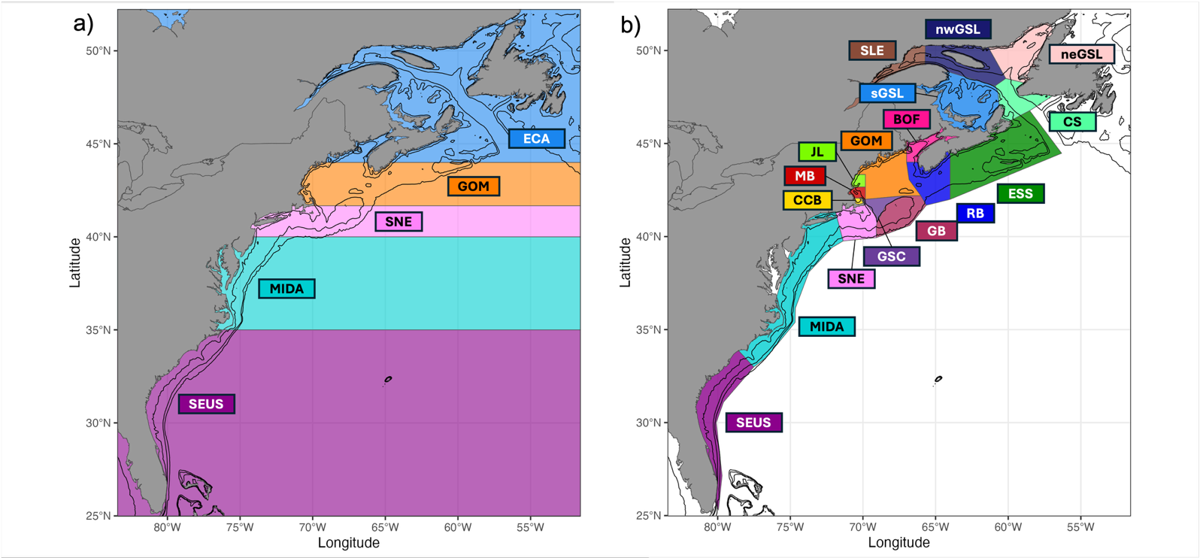
Sightings of known individuals were filtered for the first recorded location of an individual per day (n = 67,840) during the years 1980-2022. These
Every individual right whale in the population is known
